**Lab Number: 08**

**XML**

**Task Number: 01**

Create an XML document structuring information for a store. (shopping store of your choice)

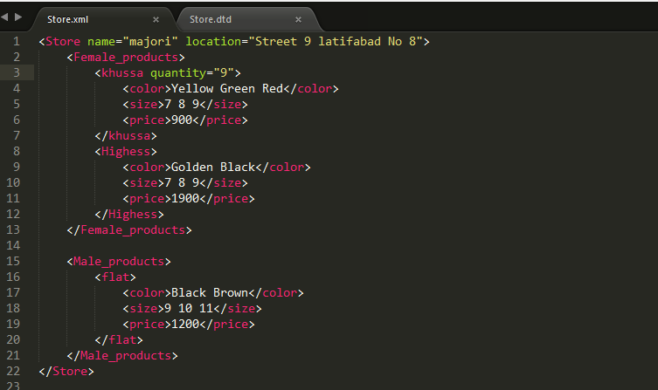

**Task Number: 02**Create DTD for store XML Document. And validate.

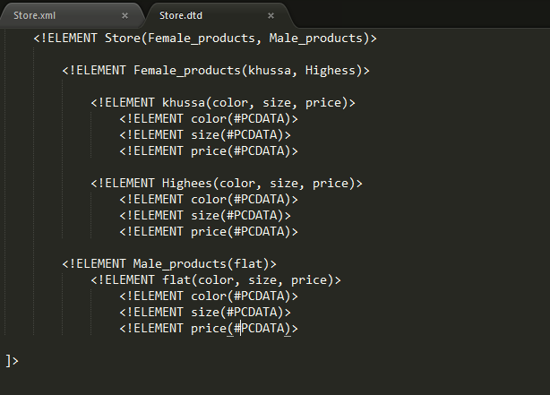

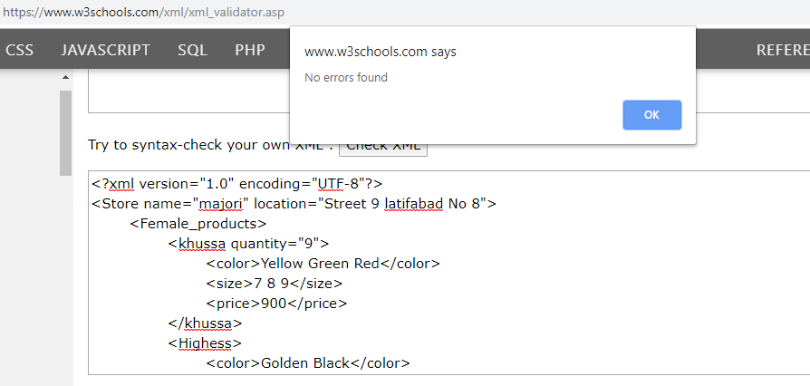

**Task Number: 03**

Write XML Schema for the following XML document and then validate the XML document along with its schema.

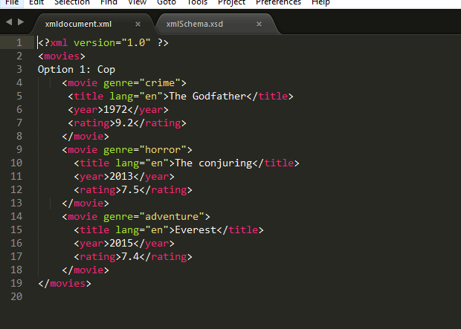

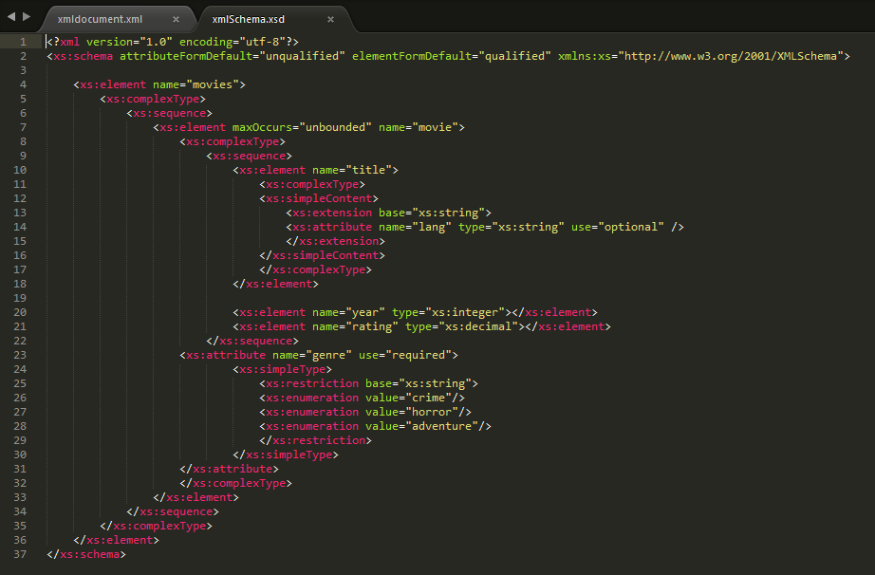

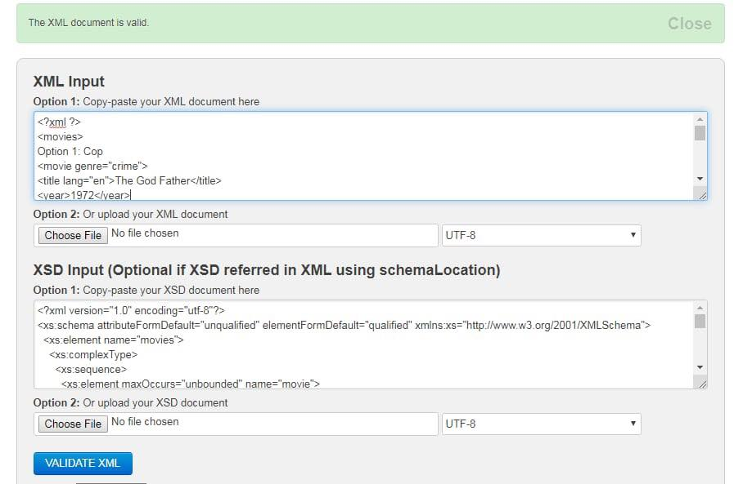

**Task Number: 04**

Write an XML instance for following schema and then

parse that document in Java using either DOM or SAX API.

